1. **Linear Regression:**

Summary of the Sales data

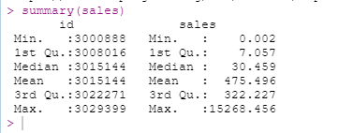

***Simple linear regression***

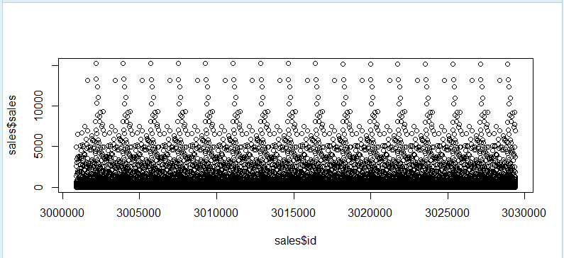

***Linear correlation***



1. **Random forest**

Load the dataset and make id as dependent variable



